EECS2311: SOFTWARE DEVELOPMENT PROJECT

User Manual: MusicXML Player and Viewer

### February 20, 2022

### PREPARED FOR

Vassilios Tzerpos,

Students of Lassonde School of Engineering

&

Musicians

### PREPARED BY

Hiba Jaleel - 215735020

Kuimou Yi - 216704819

Kamsi Idimogu - 216880288

Maaz Siddiqui - 216402927

Table of Contents

**G****etting Started** **3**

**Guide to Importing Project** **4**

**Setting up Gradle Views** **6**

**Running Application** **7**

**Previewing Music Sheet** **8**

**Saving Music Sheet as PDF** **9**

**Playing Music** **10**

**Exiting Program** **10**

# 

# 

# Getting Started

The steps to getting the project on your computer are as follows:

1. Open Eclipse, ensure that you have the Gradle add-on installed.
2. Using the following link: <https://github.com/CCSCovenant/TAB2XML> import the project. Ensure that the master branch is the one that is pulled.
3. Run the application using the Gradle Task.
4. After the program is run, a new MUSICXML window should open.
5. Paste your text-based tablature into the text box.
6. Press the ‘Preview Music Sheet’ button if you would like to see the text-based tablature in music sheet form. Press the ‘Export PDF’ button if you would like to save the music sheet.
7. Press the ‘Play Music’ button if you would like to hear the text-based tablature played.

# Guide to Importing Project

Open the Eclipse application. To import this project from GitHub, select File → Import → Git → Projects from Git (with smart import). Then, press the ‘Next’ option.

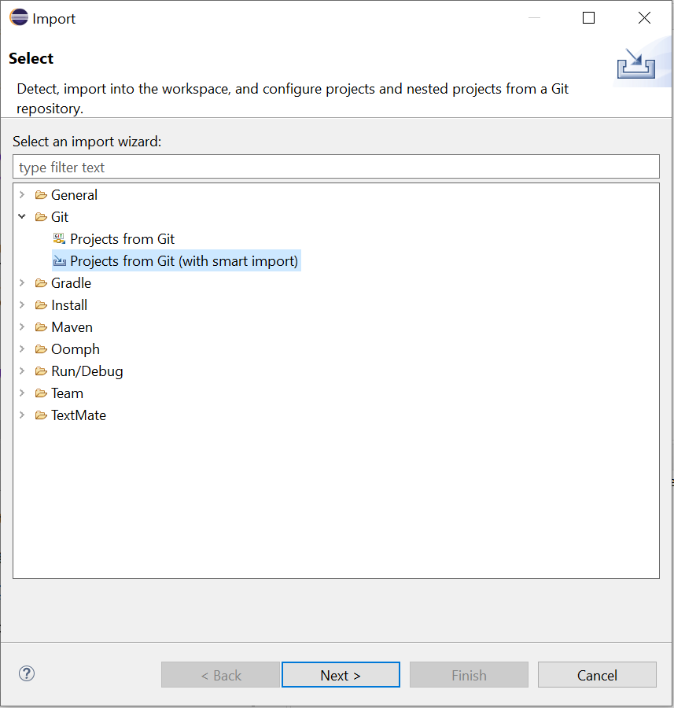

Out of the two options, select the option to ‘Clone URI.’ Then, press the ‘Next’ option.

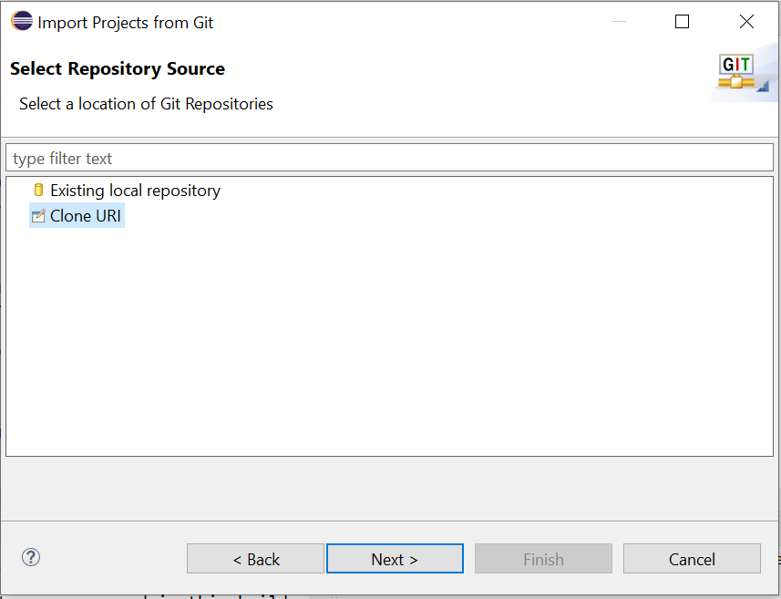

Paste the following link in the ‘URI:’ box as the location of the project. Fill in the authentication as required.   
  
<https://github.com/CCSCovenant/TAB2XML>

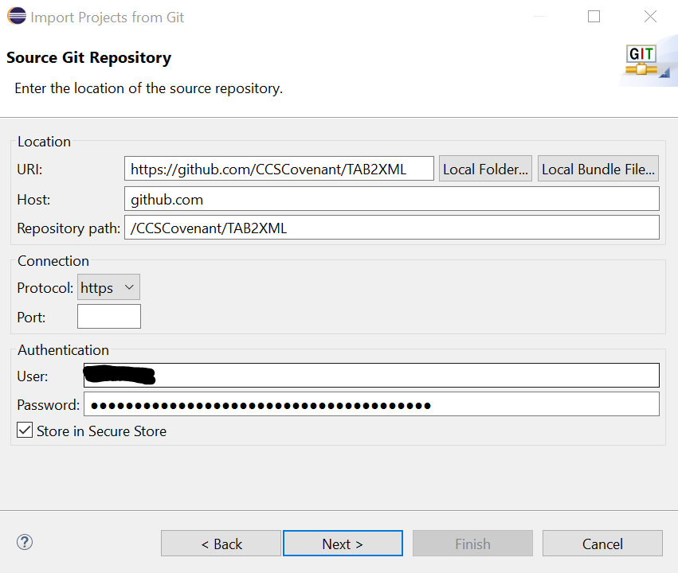

Now, we can proceed with running this program.

In order to avoid any issues, first refresh the Gradle project. Right-click the ‘build.gradle’ file, select Gradle → Refresh Gradle Project.

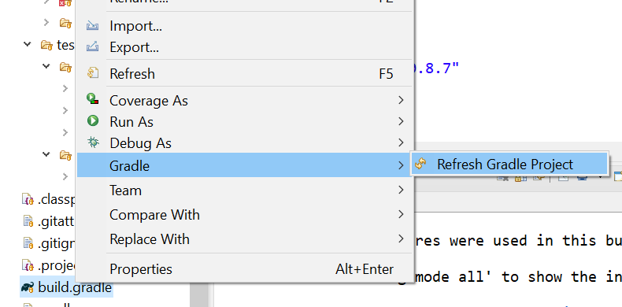

# Setting up Gradle Views

Open the Gradle Tasks and Gradle Executions views on Eclipse. Select Window → Show View → Other.

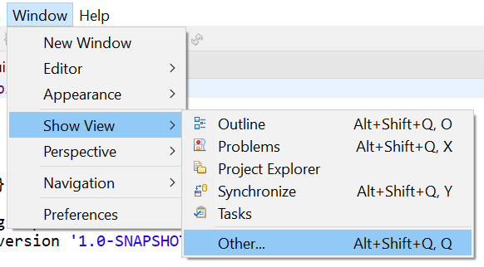

In the new window, select Gradle from the drop-down menu and select both the Gradle views, ‘Gradle Executions’ and ‘Gradle Tasks. Select ‘Open.’ These views should now be available where your console or J-Units are in the Eclipse IDE.

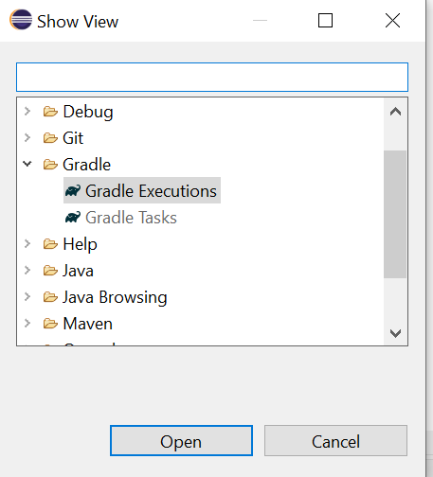

# Running Application

Under the ‘Gradle Tasks’ view, find the project and expand on it from the drop down option. Select and expand on the ‘application.’ Double-click the ‘run’ option under ‘application’ to execute the program.

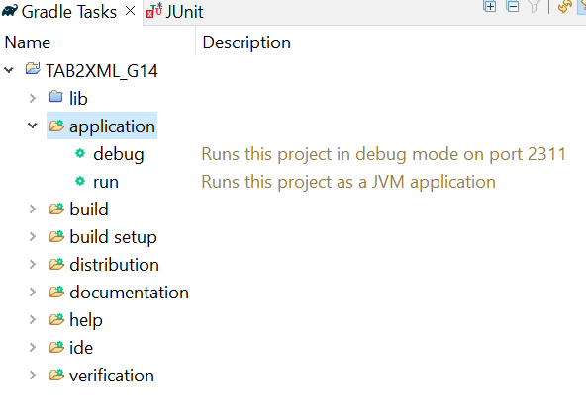

Eclipse should open a new window, looking like the following:

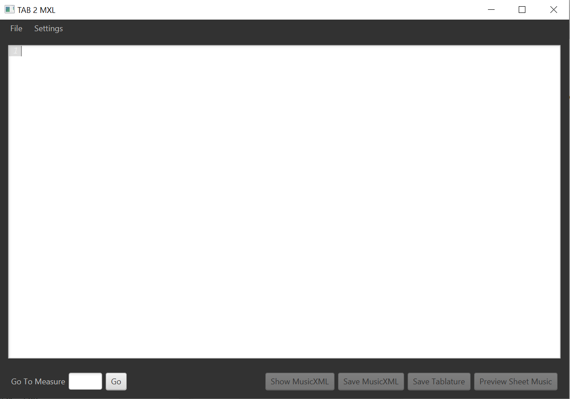

# Previewing Music Sheet

In order to preview text-based tablature as a music sheet, paste the tablature in the text-box of the window, as shown below.

Note: sheet visualize function currently under development and not support following elements of staff in the prototype:

Key

Technical

Grace

dot

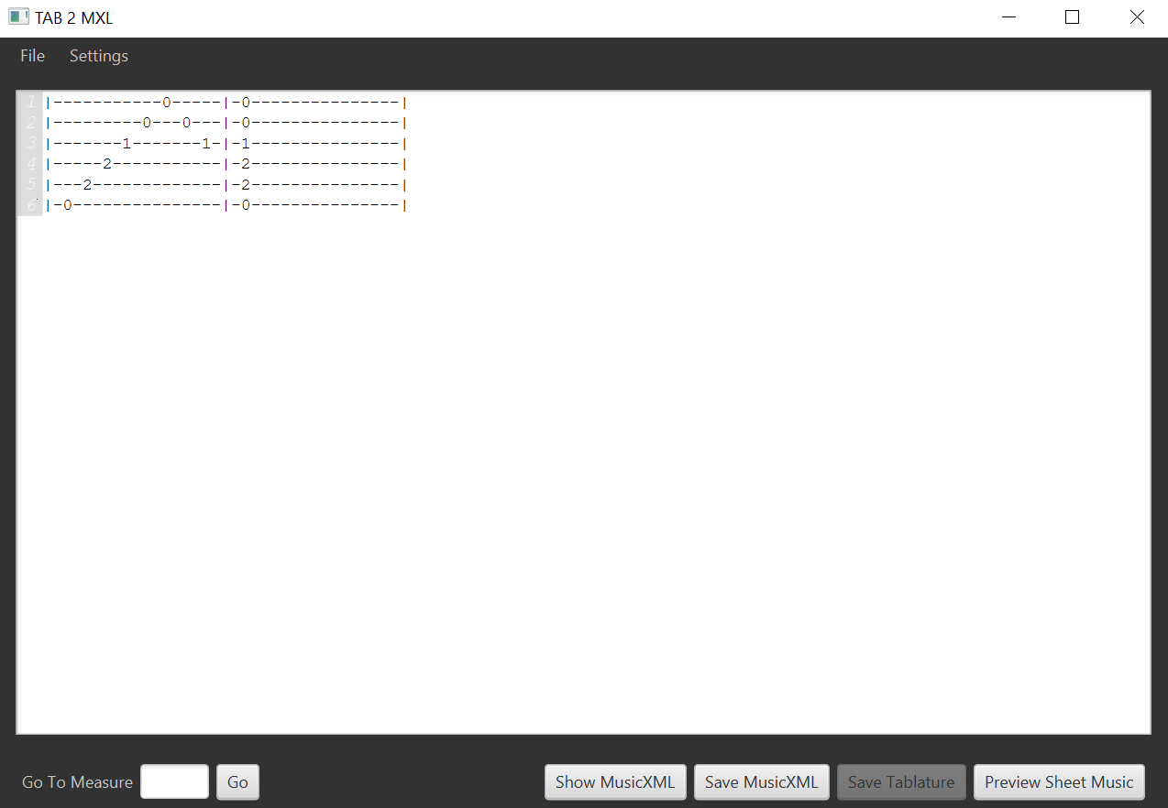

Click on ‘Preview Sheet Music’ to preview the text-based tablature as a music sheet.

# 

The music sheet should be in the following form:

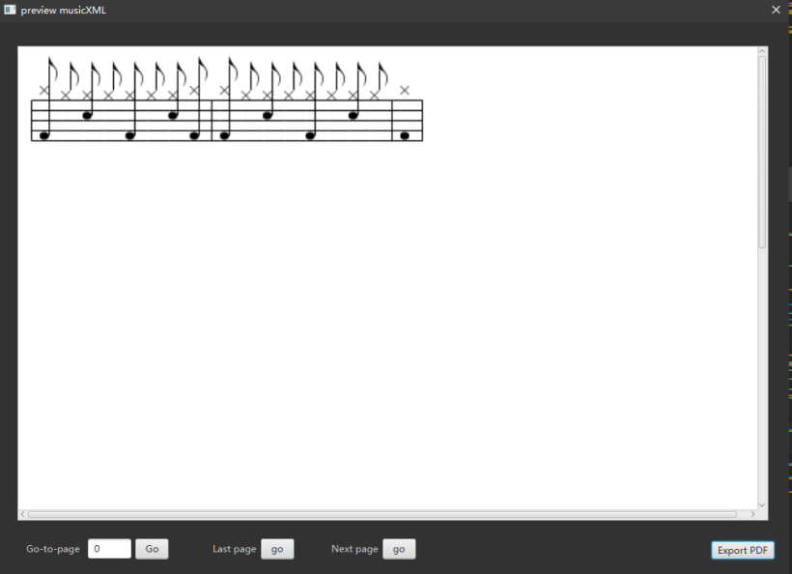

# Saving Music Sheet as PDF

To save the music sheet as a PDF, follow the steps to preview a music sheet above, then, click the ‘Export PDF’ button to save the music sheet.

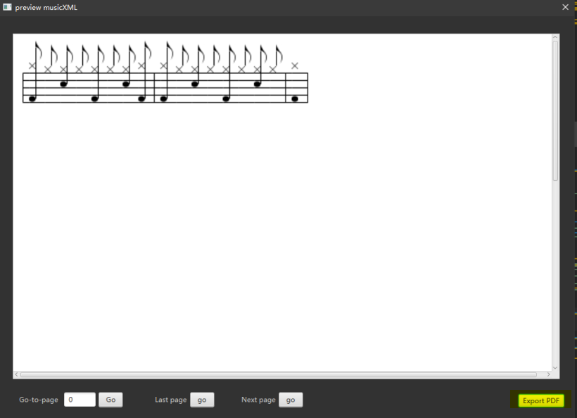

# 

# Playing Music

In order to play the music, follow the steps to preview a music sheet above, then, click the ‘play’ button to play the music sheet.

Note: playing function currently under development and not available in the prototype

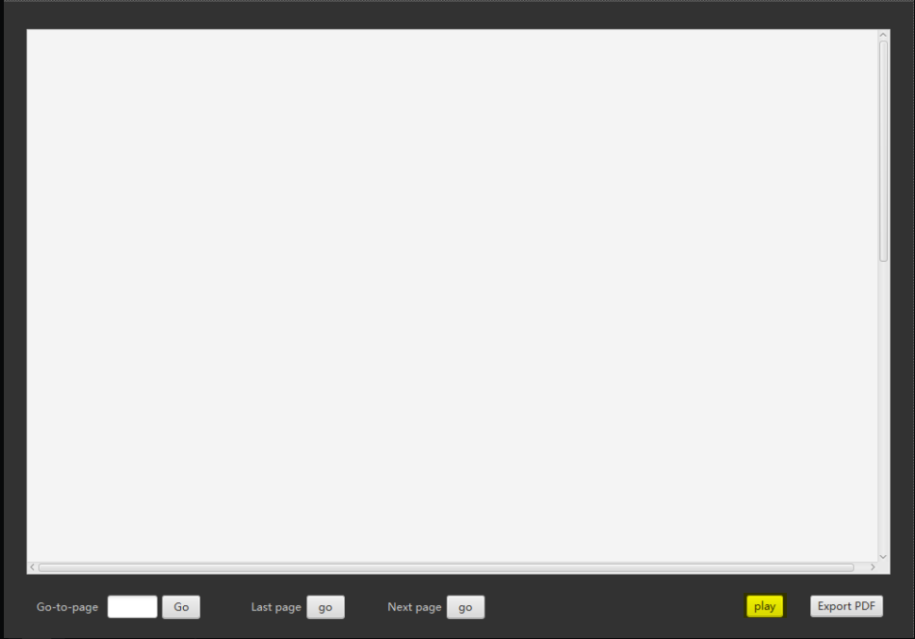

# Exiting Program

To exit the program, simply click on the red X button on the top right of the window. This will close the program. Exit Eclipse following the same steps.

